1. **INTRODUCTION**

Welcome to "Super Pirate" – an exhilarating 2D platformer runner game set in the thrilling world of swashbuckling pirates! Developed within the dynamic pygame framework, "Super Pirate" invites players to embark on a daring adventure filled with treasure, challenges, and endless excitement.

In this fast-paced arcade-style game, players assume the role of a courageous pirate captain on a quest for riches and glory. As they navigate through treacherous landscapes, braving perilous obstacles and evading cunning adversaries, they must demonstrate quick reflexes, nimble agility, and unwavering determination to emerge victorious.

Drawing inspiration from classic platformer games and infused with a vibrant pirate theme, "Super Pirate" offers a captivating blend of action-packed gameplay, immersive visuals, and captivating soundscapes. From navigating treacherous terrain to engaging in heart-pounding chase sequences, every moment in "Super Pirate" promises adrenaline-fueled excitement and pulse-pounding thrills.

With intuitive controls, dynamic level designs, and a host of power-ups and collectibles to discover, "Super Pirate" ensures endless replay ability and challenges players to push their limits and conquer new heights of piratical prowess.

But beware, matey – the high seas are fraught with danger, and only the bravest and most skillful pirates will prevail! Are you ready to embark on the adventure of a lifetime and become the ultimate Super Pirate?

1. **PROBLEM DOMAIN**

"Super Pirate," a 2D platformer runner game developed using the Pygame framework, the problem domain involves identifying and addressing challenges, limitations, and potential obstacles encountered during the development and implementation process. Here's an overview of the problem domain tailored to your project:

1. Game Mechanics: Designing engaging and balanced game mechanics is crucial for creating an enjoyable gameplay experience. Challenges may arise in defining player controls, character movement physics, obstacle placement, and progression pacing to ensure that the game remains challenging yet fair.
2. Level Design: Crafting compelling level designs with diverse obstacles, platforms, and environmental hazards requires careful planning and iteration. Balancing difficulty progression, pacing, and player engagement while maintaining thematic coherence poses challenges for level designers.
3. Collision Detection and Physics: Implementing accurate collision detection and physics simulation is essential for realistic and responsive gameplay. Ensuring that collisions between game objects are detected reliably and that player movements are governed by consistent physics rules can be technically challenging.
4. Art and Animation: Creating visually appealing art assets and animations that convey the pirate theme and enhance player immersion requires artistic skill and creativity. Challenges may arise in designing character sprites, background elements, and visual effects that align with the game's aesthetic vision.
5. Performance Optimization: Optimizing game performance to achieve smooth frame rates and responsive controls on various hardware configurations is essential for a positive user experience. Challenges may arise in optimizing resource usage, minimizing rendering bottlenecks, and managing memory efficiently within the Pygame framework.
6. Audio Integration: Integrating sound effects and background music seamlessly into the game enhances immersion and atmosphere. Challenges may arise in selecting and implementing audio assets, synchronizing sound effects with gameplay events, and optimizing audio performance for different platforms.
7. User Interface Design: Designing intuitive and visually appealing user interfaces for menus, HUD elements, and in-game notifications enhances usability and player engagement. Challenges may arise in balancing functionality with aesthetics, optimizing layout for different screen resolutions, and ensuring accessibility for all players.
8. Testing and Debugging: Thorough testing and debugging are essential for identifying and fixing bugs, glitches, and gameplay issues. Challenges may arise in implementing effective testing strategies, reproducing and isolating bugs, and ensuring compatibility across different devices and platforms.
9. Cross-Platform Compatibility: Ensuring that the game functions consistently across different operating systems and hardware configurations requires careful consideration of platform-specific quirks and limitations. Challenges may arise in addressing compatibility issues, optimizing performance for specific platforms, and adapting user interfaces for different input devices.
10. Project Management: Managing the development process, coordinating team efforts, and meeting project deadlines require effective project management skills. Challenges may arise in prioritizing tasks, allocating resources, and resolving conflicts to ensure the timely completion of the project.

**3. SOLUTION DOMAIN**

"Super Pirate," a 2D platformer runner game developed in the Pygame framework, involves outlining the specific strategies, techniques, and approaches you'll employ to address the challenges and requirements of your project. Here's an overview of the solution domain tailored to our game:

1. **Game Mechanics Design:**

* Define intuitive and responsive player controls for character movement, jumping, and interaction with game elements.
* Implement dynamic obstacle generation and placement algorithms to ensure varied and challenging gameplay experiences.
* Incorporate power-ups, collectibles, and rewards to incentivize player progression and engagement.
* Design innovative gameplay mechanics that align with the pirate theme and enhance immersion.

1. **Level Design:**

* Create meticulously crafted levels with increasing difficulty, incorporating diverse obstacles, platforms, and environmental hazards.
* Iterate on level layouts and pacing to maintain a balance between challenge and enjoyment.
* Integrate thematic elements such as pirate ships, tropical islands, and hidden treasures into level designs to enrich the game world.

1. **Collision Detection and Physics:**

* Implement efficient collision detection algorithms to accurately detect and resolve collisions between game objects.
* Utilize Pygame's built-in physics capabilities or custom physics calculations to simulate realistic movement and interactions.
* Fine-tune physics parameters such as gravity, friction, and acceleration to achieve responsive and intuitive gameplay.

1. **Art and Animation:**

* Create visually stunning art assets, including character sprites, background scenery, and special effects, that capture the essence of the pirate theme.
* Animate character movements, enemy behaviors, and environmental elements to add life and personality to the game world.
* Optimize art assets for performance and memory usage to ensure smooth rendering on a variety of devices.

1. **Performance Optimization:**

* Profile and optimize critical sections of code, such as rendering and physics calculations, to improve overall game performance.
* Implement resource management techniques to minimize memory usage and maximize efficiency.
* Utilize Pygame's hardware acceleration features and rendering optimizations to achieve smooth frame rates on a range of hardware configurations.

1. **Audio Integration:**

* Curate a selection of high-quality sound effects and background music tracks that complement the pirate theme and enhance the atmosphere.
* Implement audio cues for gameplay events such as jumps, collisions, and power-up activations to provide feedback and immersion.
* Optimize audio playback for performance and compatibility across different platforms and devices.

1. **User Interface Design:**

* Design intuitive and visually appealing user interfaces for menus, settings, and in-game HUD elements using Pygame's GUI capabilities.
* Implement navigation controls and interactive elements that are easy to understand and use for players of all skill levels.
* Ensure accessibility and readability by considering factors such as screen resolution, font size, and color contrast.

1. **Testing and Debugging:**

* Develop comprehensive testing plans to identify and address bugs, glitches, and gameplay issues throughout the development process.
* Utilize Pygame's debugging tools and logging functionality to track down and diagnose problems quickly and effectively.
* Conduct playtesting sessions with target audiences to gather feedback and iterate on game design and mechanics accordingly.

1. **SYSTEM DOMAIN**

The development, functionality, and deployment of my game within the Pygame framework. Here's an overview of the system domain tailored to my project:

1. Pygame Module: Pygame is a set of Python modules designed for writing video games. It provides functionality for handling graphics, sound, input devices, and other multimedia elements necessary for game development.
2. Python Programming Language: Since you're using Pygame, proficiency in Python programming language is crucial. You'll be writing code to implement game mechanics, handle player input, manage game states, and interact with Pygame's functionality.
3. Game Loop: The game loop is a fundamental concept in game development that controls the flow of the game. In Pygame, you'll implement a game loop that continuously updates the game state, handles user input, and renders graphics on the screen.
4. Sprites and Animation: Pygame allows you to create and manipulate sprites, which are 2D images representing game objects such as characters, obstacles, and collectibles. You'll use sprites to animate characters, simulate movement, and interact with the game environment.
5. Collision Detection: Implementing collision detection is essential for detecting when game objects intersect with each other. In your 2D platformer runner game, collision detection ensures that the player character can interact with platforms, obstacles, and other game elements accurately.
6. Level Design: Designing engaging levels with varied obstacles, platforms, and challenges is essential for keeping players entertained and challenged. You'll use Pygame to create level layouts, place objects within the game world, and define the progression of gameplay.
7. Input Handling: Pygame provides functionality for handling user input from keyboard, mouse, or other input devices. You'll write code to interpret player actions such as jumping, ducking, and moving left or right, and translate them into game mechanics within your 2D platformer runner game.
8. Audio Integration: Adding sound effects and background music enhances the gaming experience. Pygame allows you to load and play audio files, synchronize sound effects with in-game events, and create immersive audio environments for your game.
9. Optimization and Performance: Optimizing your game for performance ensures smooth gameplay and consistent frame rates. Techniques such as sprite batching, efficient rendering, and memory management help optimize resource usage and maximize performance within the Pygame framework.
10. Debugging and Testing: Thorough testing and debugging are essential for identifying and fixing errors, glitches, and gameplay issues. Pygame provides debugging tools and techniques for testing game functionality, verifying behaviour, and ensuring overall stability
11. **APPLICATION DOMAIN**

"Super Pirate," a 2D platformer runner game developed using the Pygame framework, the application domain encompasses the specific context, audience, and purpose of your game within the realm of gaming and entertainment. Here's an overview of the application domain tailored to our project:

1. Gaming Industry: Your game operates within the broader gaming industry, which encompasses various genres, platforms, and player demographics. Understanding market trends, player preferences, and industry standards helps position your game effectively within this competitive landscape.
2. 2D Platformer Genre: "Super Pirate" belongs to the 2D platformer genre, characterized by side-scrolling gameplay, jumping mechanics, and obstacle traversal. Familiarity with popular games in this genre, both classic and contemporary, informs your design decisions and influences player expectations.
3. Endless Runner Subgenre: Within the 2D platformer genre, "Super Pirate" specifically falls into the subgenre of endless runners, where the player's character continuously moves forward, and the goal is to survive as long as possible while avoiding obstacles and collecting rewards. Analysing existing endless runner games helps identify successful gameplay mechanics and engagement strategies.
4. Pirate Theme: The theme of piracy adds a unique flavour to your game, influencing the visual aesthetics, character design, level environments, and storytelling elements. Incorporating elements such as treasure hunting, naval adventures, and swashbuckling action aligns with the pirate theme and enhances player immersion.
5. Target Audience: Identifying your target audience is crucial for tailoring the game experience to their preferences and interests. "Super Pirate" may appeal to casual gamers, platformer enthusiasts, or players seeking accessible and engaging gameplay experiences. Understanding the demographics, gaming habits, and preferences of your target audience guides your design and marketing efforts.
6. Accessibility and Inclusivity: Designing your game to be accessible and inclusive ensures that players of all ages, abilities, and backgrounds can enjoy the experience. Incorporating features such as adjustable difficulty levels, intuitive controls, and inclusive character representation promotes inclusivity and broadens your game's appeal.
7. Entertainment and Engagement: Ultimately, the application domain of "Super Pirate" revolves around providing entertainment, enjoyment, and engagement to players. By delivering dynamic gameplay, responsive controls, and rewarding progression, your game aims to captivate and delight its audience, fostering long-term player engagement and loyalty.
8. Platform Compatibility: Since your game is developed using the Pygame framework, it's important to consider platform compatibility. Pygame supports deployment on various platforms, including Windows, macOS, Linux, and others. Ensuring smooth performance and consistent user experience across different platforms enhances the accessibility and reach of your game.
9. **EXPECTED OUTCOME**

The expected outcome in a 2D game can vary depending on the specific game and its genre.

However, some common expected outcomes for 2D games include:

Completing a level or series of levels: Many 2D games are structured around completing a series

of levels, either through exploration or overcoming obstacles. The expected outcome is to

progress through each level until the end of the game.

Achieving a high score: In many arcade-style 2D games, players aim to achieve the highest score

possible by completing tasks, collecting items, or defeating enemies.

Defeating a boss: Many 2D games feature boss battles at the end of levels or chapters, where the

player must defeat a powerful enemy to progress.

Multiplayer competition: In some 2D games, the expected outcome is to outscore or outlast other

players in multiplayer competitions.

Ultimately, the expected outcome in a 2D game is to provide a satisfying gameplay experience

that challenges and entertains the player.

The expected outcome in a 2D game can vary depending on the specific game and its genre.

However, some common expected outcomes for 2D games include:

Completing a level or series of levels: Many 2D games are structured around completing a series

of levels, either through exploration or overcoming obstacles. The expected outcome is to

progress through each level until the end of the game.

Achieving a high score: In many arcade-style 2D games, players aim to achieve the highest score

possible by completing tasks, collecting items, or defeating enemies.

Defeating a boss: Many 2D games feature boss battles at the end of levels or chapters, where the

player must defeat a powerful enemy to progress.

Multiplayer competition: In some 2D games, the expected outcome is to outscore or outlast other

players in multiplayer competitions.

Ultimately, the expected outcome in a 2D game is to provide a satisfying gameplay experience

that challenges and entertains the player.

"Super Pirate," a 2D platformer runner game developed in the Pygame framework, encompasses several key aspects that contribute to the success and effectiveness of your project. Here's an overview of the expected outcomes tailored to our game:

1. **Engaging Gameplay Experience:**

* Players should be captivated by the immersive pirate-themed world and addictive gameplay mechanics.
* The game should offer a challenging yet accessible experience that keeps players coming back for more.

1. **Smooth Performance and Stability:**

* The game should run smoothly on a variety of devices and platforms, maintaining consistent frame rates and responsiveness.
* Stability is crucial, with minimal crashes, bugs, or technical issues disrupting the player experience.

1. **Visually Stunning Art and Animation:**

* The game's art style and animation should be visually appealing and cohesive, capturing the essence of the pirate theme.
* Character sprites, background scenery, and special effects should be well-designed and polished, enhancing immersion.

1. **Immersive Audio Experience:**

* High-quality sound effects and background music should complement the gameplay and enhance the atmosphere of the pirate world.
* Audio cues for gameplay events should provide feedback and contribute to player engagement and immersion.

1. **Intuitive User Interface:**

* The user interface should be intuitive and easy to navigate, allowing players to access settings, controls, and information effortlessly.
* Accessibility considerations should ensure that the UI is readable and usable for players of all skill levels and abilities.

1. **Dynamic Level Design:**

* Levels should be meticulously crafted with varied obstacles, platforms, and challenges that offer a rewarding progression curve.
* Each level should present unique gameplay experiences while maintaining thematic coherence within the pirate world.

1. **Responsive Controls and Mechanics:**

* Player controls should be responsive and precise, allowing for fluid and satisfying movement and interaction with the game world.
* Gameplay mechanics such as jumping, dodging, and collecting should feel natural and intuitive, enhancing the overall player experience.

1. **Positive Player Feedback and Engagement:**

* Playtesting and player feedback should indicate high levels of satisfaction and engagement with the game.
* Positive reviews and ratings from players should reflect the quality and enjoyment of the gameplay experience.

1. **Market Recognition and Success:**

* "Super Pirate" should garner attention and recognition within the gaming community, attracting a loyal player base and positive word-of-mouth promotion.
* The game's success may be measured by factors such as downloads, active players, revenue (if applicable), and awards or accolades received.

**Requirement specification (Hardware and software requirement) in 2D game**

* **Software Specification:**
* Python
* OS (Windows, Linux, Mac Os etc.)
* Visual Studio Code
* Chrome
* **Hardware Specification:**
* RAM - 512MB or above
* Hard Disk - 128GB or above
* **Front End:**
* HTML, CSS and JAVASCRIPT
* **Backend Technology:**
* MYSQL
* Python (Pygame)
* **Additional Requirements:**

Input devices: Keyboard and Mouse or Gamepad

Internet connection for downloading and updating game assets and patches

Game engine licenses and royalty fees, depending on the chosen engine and distribution model

**IMPLEMENTATION DETAILS**

In this Section we will do Analysis of Technologies to use for implementing the project.

**FRONT END**

**HTML:-**

Hypertext Markup Language (HTML) is the standard markup language for documents designed to be displayed in a web browser. It can be assisted by technologies such as Cascading Style Sheets (CSS) and scripting languages such as JavaScript. Web browsers receive HTML documents from a web server or from local storage and render the documents into multimedia web pages. HTML describes the structure of a web page semantically and originally included cues for the appearance of the document.

HTML elements are the building blocks of HTML pages. With HTML constructs, images and other objects such as interactive forms may be embedded into the rendered page. HTML provides a means to create structured documents by denoting structural semantics for text such as headings, paragraphs, lists, links, quotes and other items. HTML elements are delineated by tags, written using angle brackets. Tags such as <img /> and <input /> directly introduce content into the page. Other tags such as <p> surround and provide information about document text and may include other tags as sub-elements. Browsers do not display the HTML tags, but use them to interpret the content of the page.

HTML can embed programs written in a scripting language such as JavaScript, which affects the behavior and content of web pages. Inclusion of CSS defines the look and layout of content. The World Wide Web Consortium (W3C), former maintainer of the HTML and current maintainer of the CSS standards, has encouraged the use of CSS over explicit presentational HTML since 1997.

**CSS:-**

Cascading Style Sheets (CSS) is a style sheet language used for describing the presentation of a document written in a markup language like HTML.CSS is a cornerstone technology of the World Wide Web, alongside HTML and JavaScript.CSS is designed to enable the separation of presentation and content, including layout, colors, and fonts. This separation can improve content accessibility, provide more flexibility and control in the specification of presentation characteristics, enable multiple web pages to share formatting by specifying the relevant CSS in a separate .css file, and reduce complexity and repetition in the structural content.

CSS information can be provided from various sources. These sources can be the web browser, the user and the author. The information from the author can be further classified into inline, media type, importance, selector specificity, rule order, inheritance and property definition. CSS style information can be in a separate document or it can be embedded into an HTML document. Multiple style sheets can be imported. Different styles can be applied depending on the output device being used; for example, the screen version can be quite different from the printed version, so that authors can tailor the presentation appropriately for each medium. The style sheet with the highest priority controls the content display. Declarations not set in the highest priority source are passed on to a source of lower priority, such as the user agent style. The process is called cascading.

One of the goals of CSS is to allow users greater control over presentation. Someone who finds red italic headings difficult to read may apply a different style sheet. Depending on the browser and the web site, a user may choose from various style sheets provided by the designers, or may remove all added styles and view the site using the browser's default styling, or may override just the red italic heading style without altering other attributes.

**JavaScript:-**

JavaScript (js) is a light-weight object-oriented programming language which is used by several websites for scripting the webpages. It is an interpreted, full-fledged programming language that enables dynamic interactivity on websites when applied to an HTML document. It was introduced in the year 1995 for adding programs to the webpages in the Netscape Navigator browser. Since then, it has been adopted by all other graphical web browsers. With JavaScript, users can build modern web applications to interact directly without reloading the page every time. The traditional website uses js to provide several forms of interactivity and simplicity.

Although, JavaScript has no connectivity with Java programming language. The name was suggested and provided in the times when Java was gaining popularity in the market. In addition to web browsers, databases such as Couch DB and MongoDB uses JavaScript as their scripting and query language.

**BACK END**

**Python:-**

Python is a [high-level](https://en.wikipedia.org/wiki/High-level_programming_language), [general-purpose programming language](https://en.wikipedia.org/wiki/General-purpose_programming_language). Its design philosophy emphasizes [code readability](https://en.wikipedia.org/wiki/Code_readability) with the use of [significant indentation](https://en.wikipedia.org/wiki/Off-side_rule).

Python is [dynamically-typed](https://en.wikipedia.org/wiki/Type_system#DYNAMIC) and [garbage-collected](https://en.wikipedia.org/wiki/Garbage_collection_(computer_science)). It supports multiple [programming paradigms](https://en.wikipedia.org/wiki/Programming_paradigm), including [structured](https://en.wikipedia.org/wiki/Structured_programming) (particularly [procedural](https://en.wikipedia.org/wiki/Procedural_programming)), [object-oriented](https://en.wikipedia.org/wiki/Object-oriented_programming) and [functional programming](https://en.wikipedia.org/wiki/Functional_programming). It is often described as a "batteries included" language due to its comprehensive [standard library](https://en.wikipedia.org/wiki/Standard_library).

[Guido van Rossum](https://en.wikipedia.org/wiki/Guido_van_Rossum) began working on Python in the late 1980s as a successor to the [ABC programming language](https://en.wikipedia.org/wiki/ABC_(programming_language)) and first released it in 1991 as Python 0.9.0. Python 2.0 was released in 2000 and introduced new features such as [list comprehensions](https://en.wikipedia.org/wiki/List_comprehension), [cycle-detecting](https://en.wikipedia.org/wiki/Cycle_detection) garbage collection, [reference counting](https://en.wikipedia.org/wiki/Reference_counting), and [Unicode](https://en.wikipedia.org/wiki/Unicode) support. Python 3.0, released in 2008, was a major revision that is not completely [backward-compatible](https://en.wikipedia.org/wiki/Backward_compatibility) with earlier versions. Python 2 was discontinued with version 2.7.18 in 2020.

Python consistently ranks as one of the most popular programming languages.

**Pygame:-**

Pygame is a [cross-platform](https://en.wikipedia.org/wiki/Cross-platform) set of [Python](https://en.wikipedia.org/wiki/Python_(programming_language)) modules designed for writing [video games](https://en.wikipedia.org/wiki/Video_game). It includes [computer graphics](https://en.wikipedia.org/wiki/Computer_graphics) and sound [libraries](https://en.wikipedia.org/wiki/Library_(computing)) designed to be used with the Python [programming language](https://en.wikipedia.org/wiki/Programming_language).

Pygame is a set of Python modules designed for writing video games. Pygame adds functionality on top of the excellent SDL library. This allows you to create fully featured games and multimedia programs in the python language.

Pygame is highly portable and runs on nearly every platform and operating system.

Pygame itself has been downloaded millions of times.

Pygame is free. Released under the LGPL license, you can create open source, freeware, shareware, and commercial games with it. See the license for full details.

For a nice introduction to pygame, examine the line-by-line chimp tutorial, and the introduction for python programmers. Buffer, and many other different backbends... including an ASCII art backend! OpenGL is often broken on Linux systems, and also on windows systems - which is why professional games use multiple backend.

**List of Figure:-**

1. Use Case
2. Activity Diagram
3. Sequence Diagram
4. **Use case diagram**

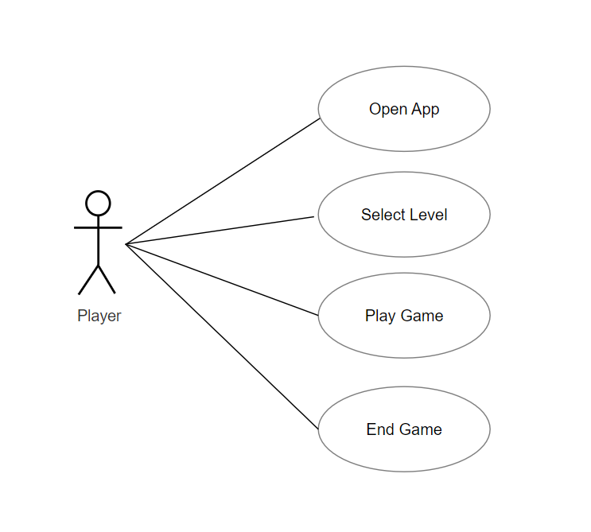

1. **Activity Diagram**

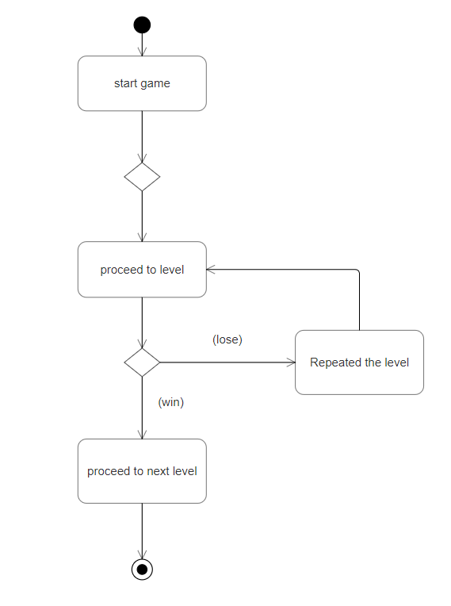

1. **Sequence Diagram**

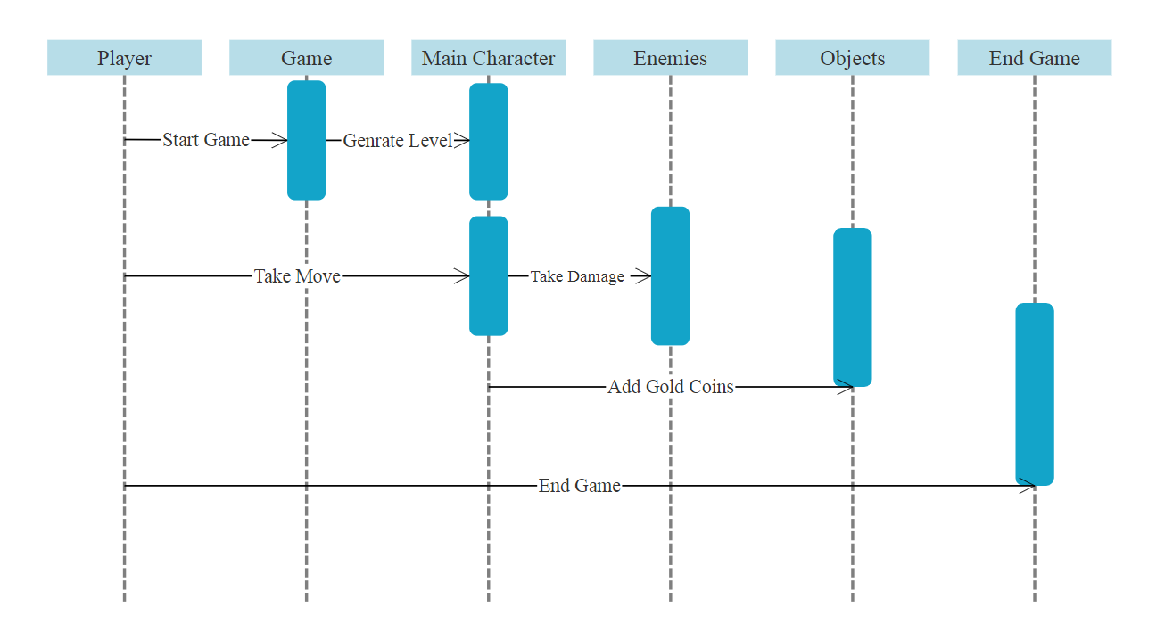

**Screenshot:-**

**Level Map:**

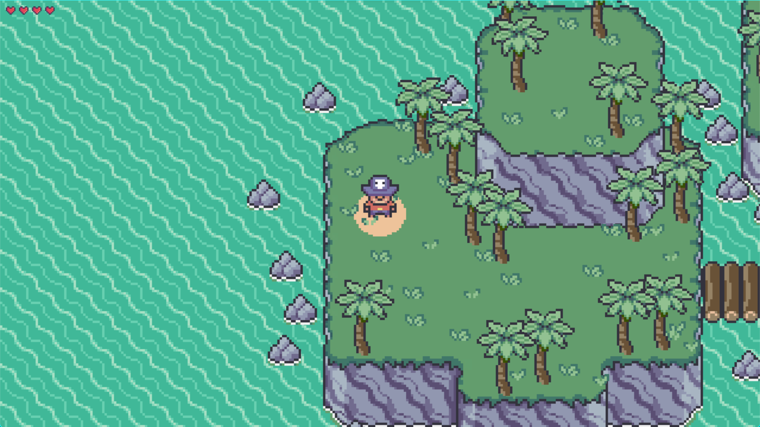

**Level 1st:-**

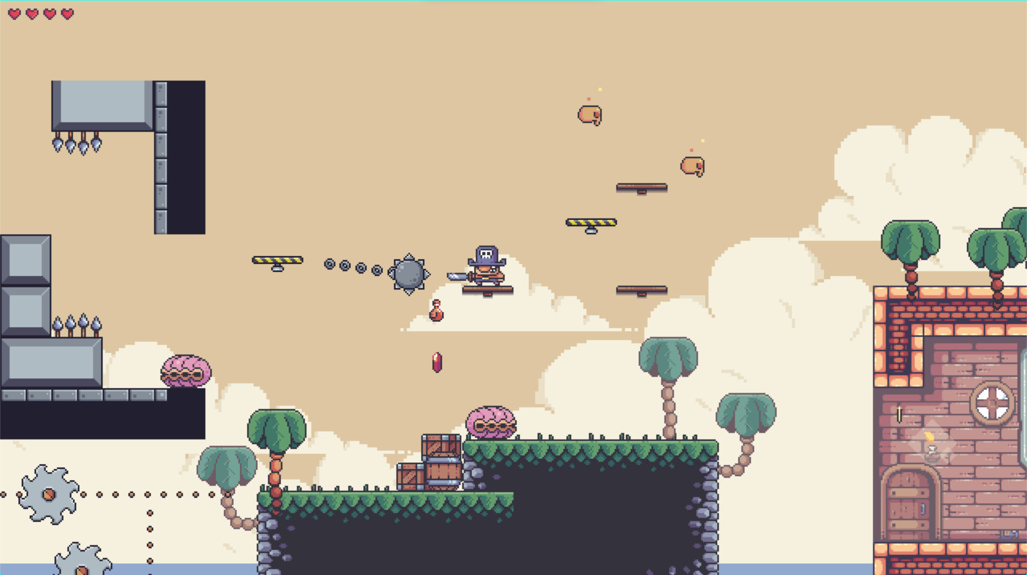

**Whole Level Map:**

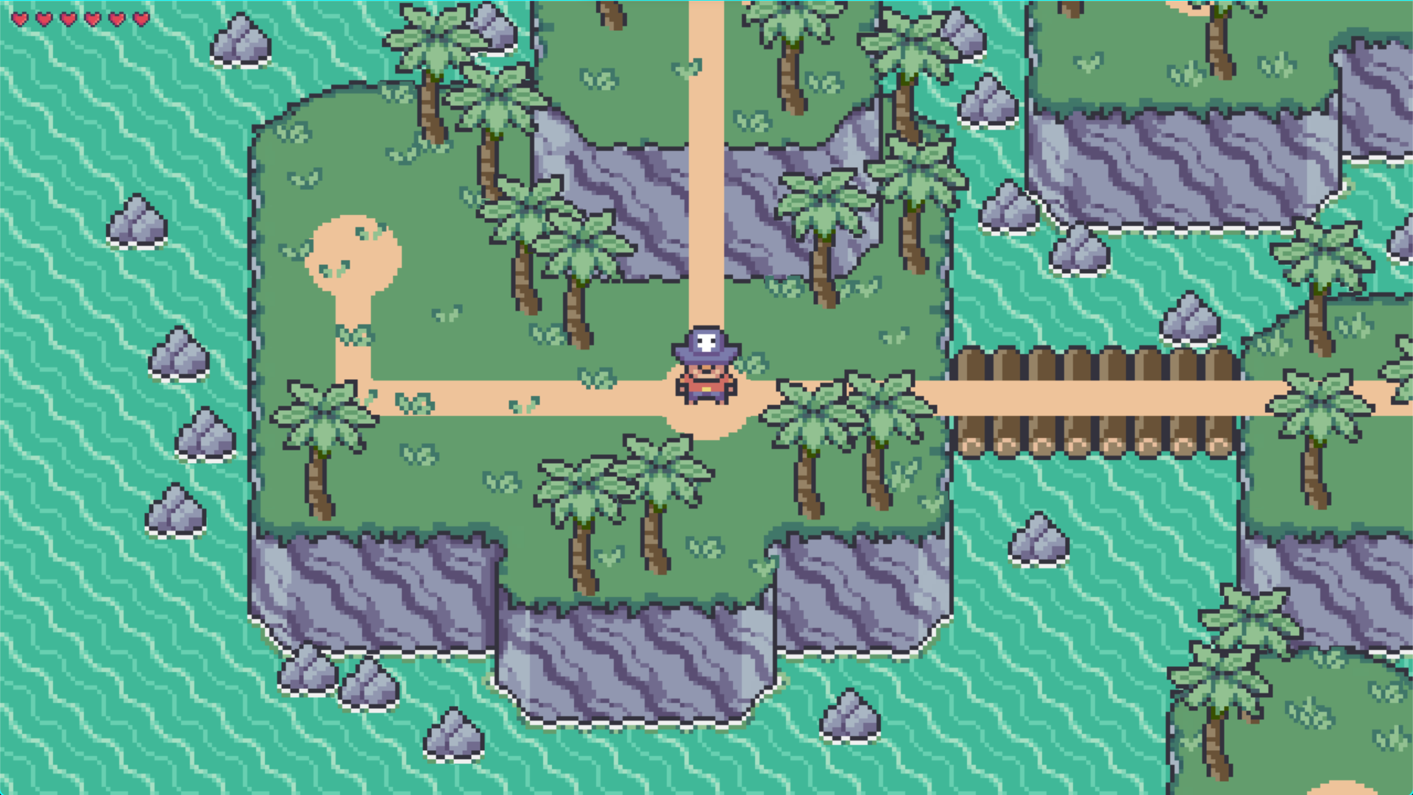

**Level 2nd**

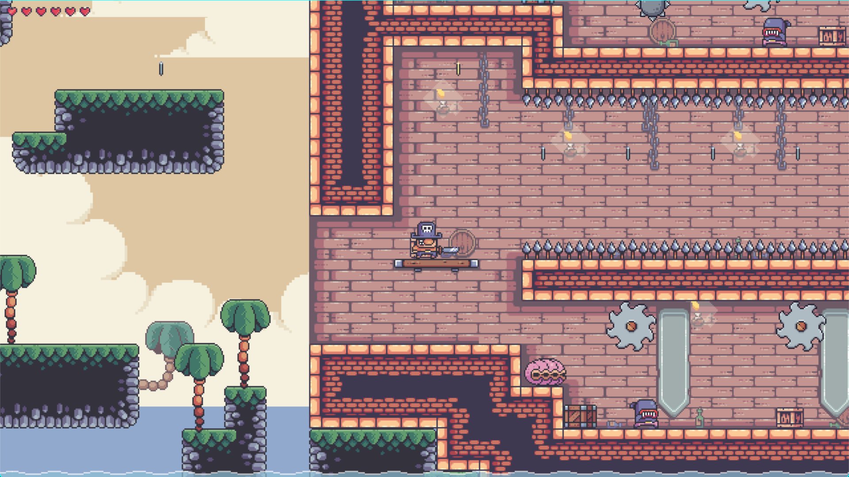

**Level 3rd**

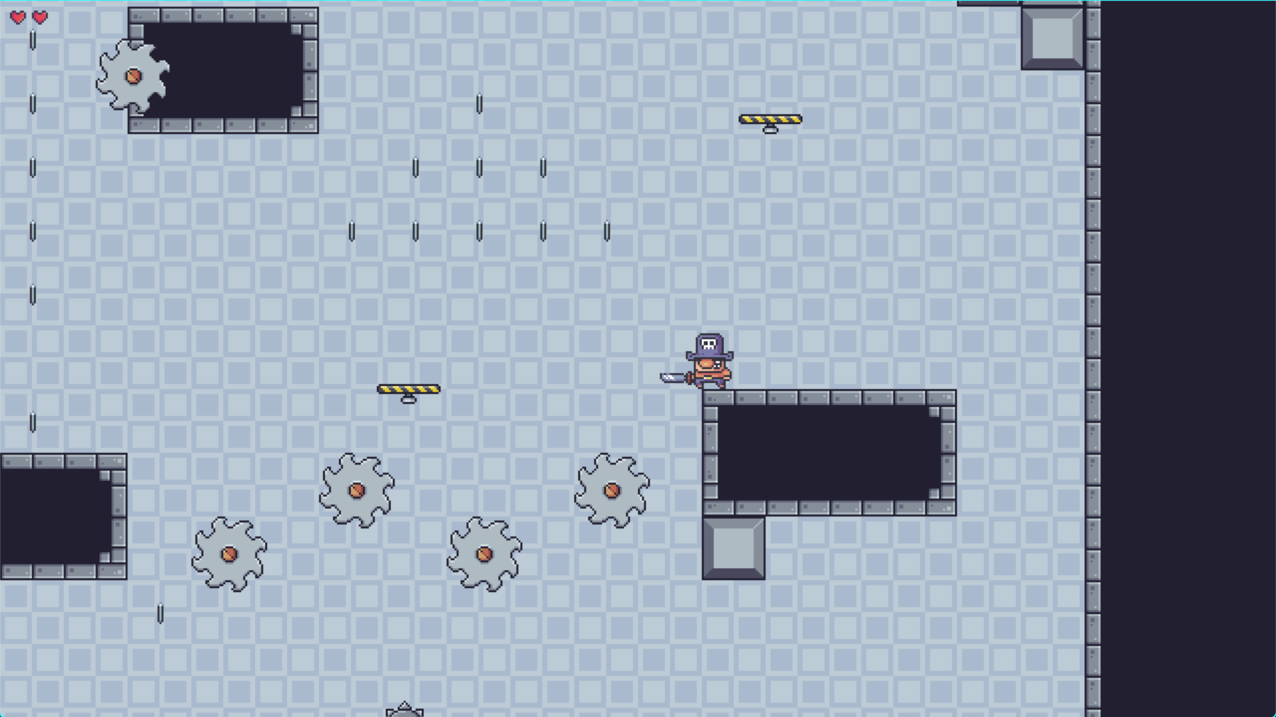

**Level 4th**

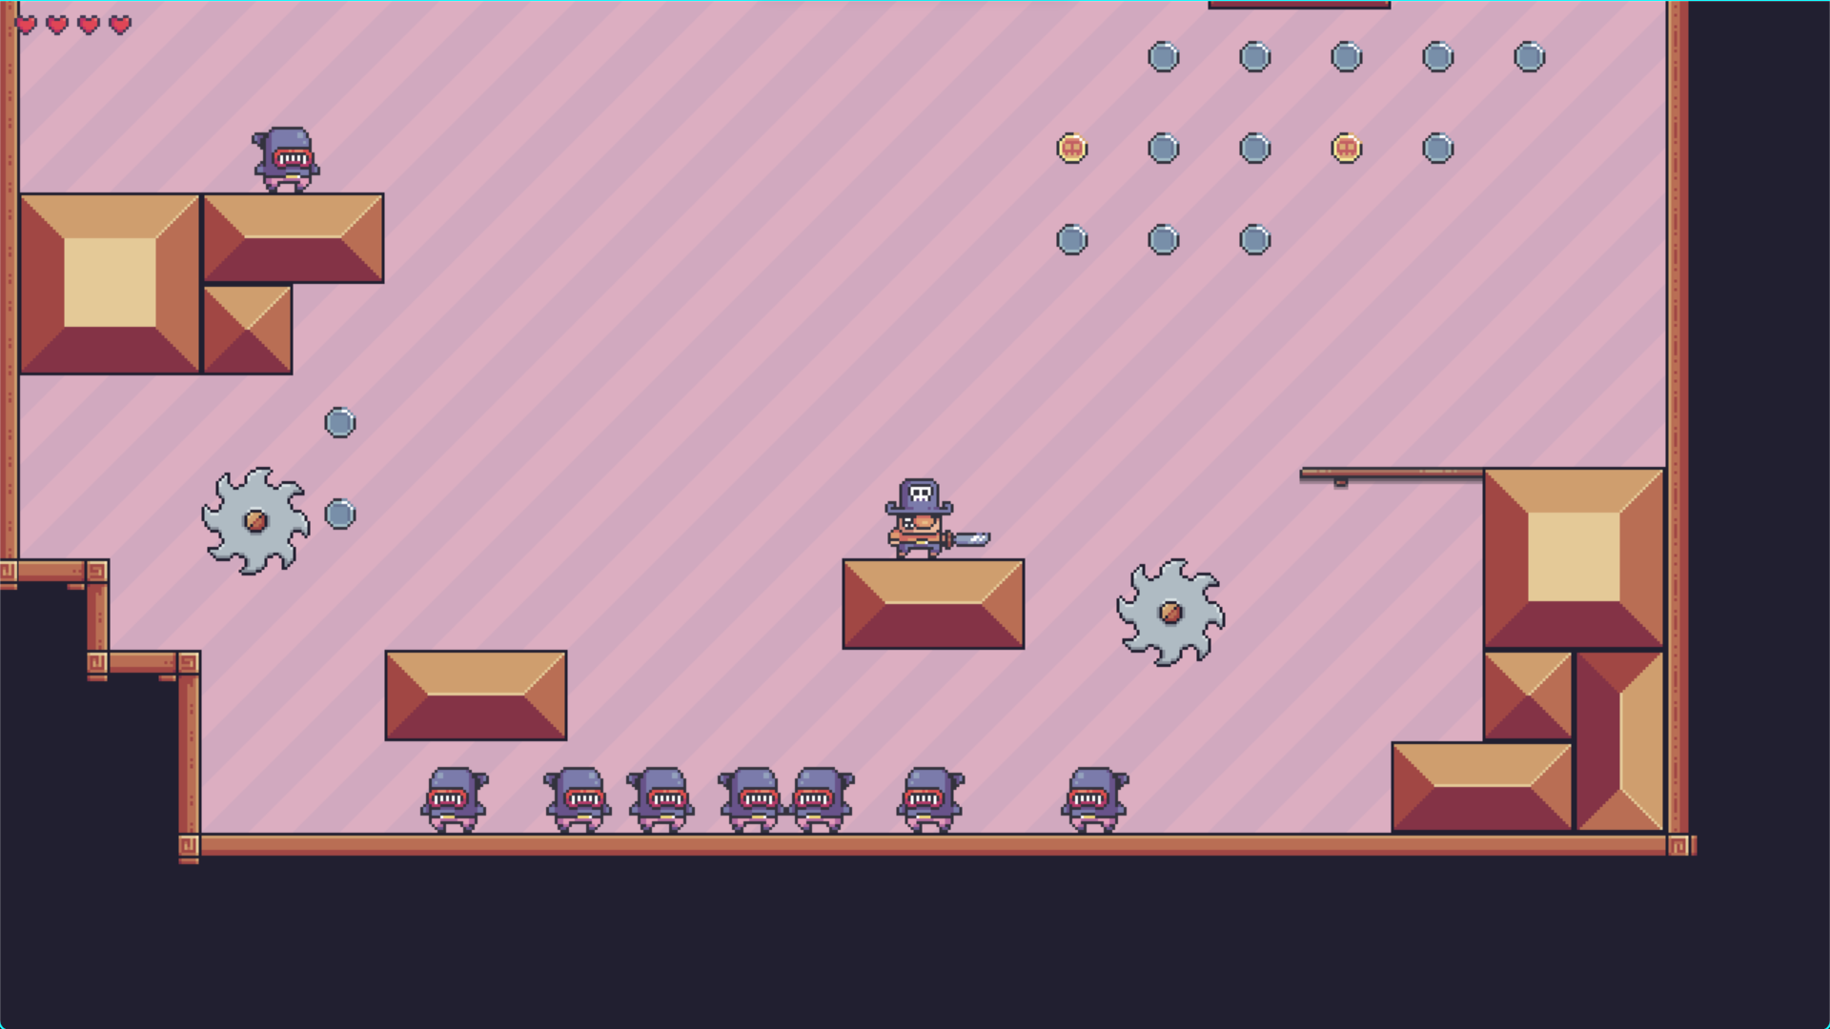

**CONCLUSION AND FUTURE SCOPE**

Mastering 2D game production necessitates a blend of technical abilities, creativity, and effective methods. Game creators may create compelling and engrossing games that catch the attention of players by understanding the key techniques and strategies involved in 2D game development. Whether you’re new to game development or have years of expertise, understanding these approaches and strategies can help you advance your talents.

This game will take the player on a journey of adventure and exploration through multiple levels and scenarios. This system can be expanded in the feature by adding more levels and enemy types, develop better AI for the enemy and NP’s (non-playable characters). Future versions of this game will bring more features and opportunities to increase the efficiency of the code and add more features.

**Reference**

[**https://www.youtube.com/clearcoding**](https://www.youtube.com/clearcoding)

[**https://github.com/clearcoding**](https://github.com/clearcoding)

<https://www.pygame.org/news>